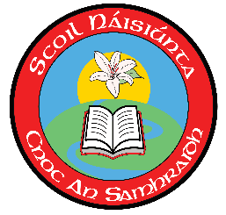
Summerhill Primary School
Athlone
Co Roscommon
Roll: 12754u

Enrolment Enquiry for the 2024/2025 School Year (Mainstream)
Please Note: This is an enquiry form only. Completion of this form does not constitute an enrolment. This form will be held on our files for the remainder of this school year. You will be invited to complete an enrolment application form if we have a place for your child. If you are not successful in obtaining a place for this school year and you wish your child to remain on our waiting list for the coming year, you will need to re-apply.

Child’s Details

Name: __________________________ Male or Female? _________________________
Address: ______________________________________________________________________________________________________________________________________________________
Date of Birth: _________________________
Class in which you are seeking to enrol: _________________________
Current pre-school / primary school: _____________________________________________

Parents’ / Guardians’ Details

Name: ____________________________ Name: ____________________________
Relationship to Child: ________________ Relationship to Child: ________________
Phone Number: _____________________ Phone Number: _____________________
Email: _____________________________ Email: _____________________________

Date of Enquiry: _______________
Name (printed): __________________________
Signature: ___________________________

